Experiment 2 — Data Visualization
Name : Prem Vijay Hanchate
Roll no : 68 Class : TE/IT

Aim
To create meaningful visualizations using bar charts and box plots on the Aadhar Enrollment dataset to represent patterns, trends, and distributions across states, districts, and age groups, and to interpret the insights derived from them.

Theory
Data Visualization is the graphical representation of data and information. It transforms raw numbers into visual formats such as charts, graphs, and plots, making it easier to identify patterns, trends, outliers, and relationships that would otherwise be difficult to detect in tabular form.
1. Importance of Visualization in Data Science: After EDA, visualization serves as the next critical step. It enables analysts to communicate findings effectively, validate assumptions, and guide decisions. Python's matplotlib and seaborn libraries are widely used for this purpose.
2. Bar Chart: A bar chart represents categorical data with rectangular bars. The height or length of each bar is proportional to the value it represents. Bar charts are ideal for comparing quantities across categories.
- Grouped Bar Chart — Displays multiple sub-categories side by side for each main category. Used here to compare age group enrollments (0–5, 5–17, 18+) across different states.
- Stacked Bar Chart — Layers sub-categories on top of each other within a single bar, showing both the total and the contribution of each part. Used here to show combined enrollment per state.
- Simple Bar Chart — Used to display the Top 10 districts by total enrollment, with value labels on each bar for easy reading.
3. Box Plot: A box plot (also called a box-and-whisker plot) summarizes the distribution of a dataset through five statistics:
- Minimum and Maximum — The ends of the whiskers (excluding outliers).
- Q1 (25th percentile) — Lower edge of the box.
- Median (Q2 / 50th percentile) — Line inside the box.
- Q3 (75th percentile) — Upper edge of the box.
- IQR (Interquartile Range) — Q3 − Q1, representing the middle 50% of data.
- Outliers — Points beyond 1.5 × IQR from Q1 or Q3, plotted as individual dots.
Box plots are ideal for comparing distributions across multiple groups and identifying skewness and outliers.
4. Data Aggregation Before Plotting: Before plotting, raw data is aggregated meaningfully:
- A new column Total_Enrollment is computed by summing the three age-group columns (age_0_5, age_5_17, age_18_greater), handling NaN values gracefully.
- Data is grouped by State (summing age-group columns) to compare state-wise enrollment.
- Data is grouped by district (summing Total_Enrollment) and sorted to extract the Top 10 districts.

Execution
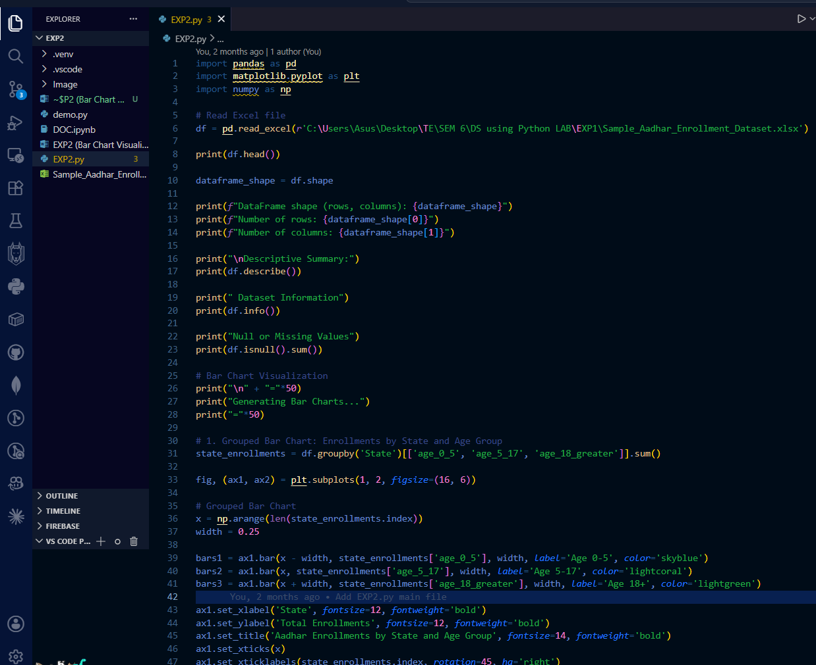


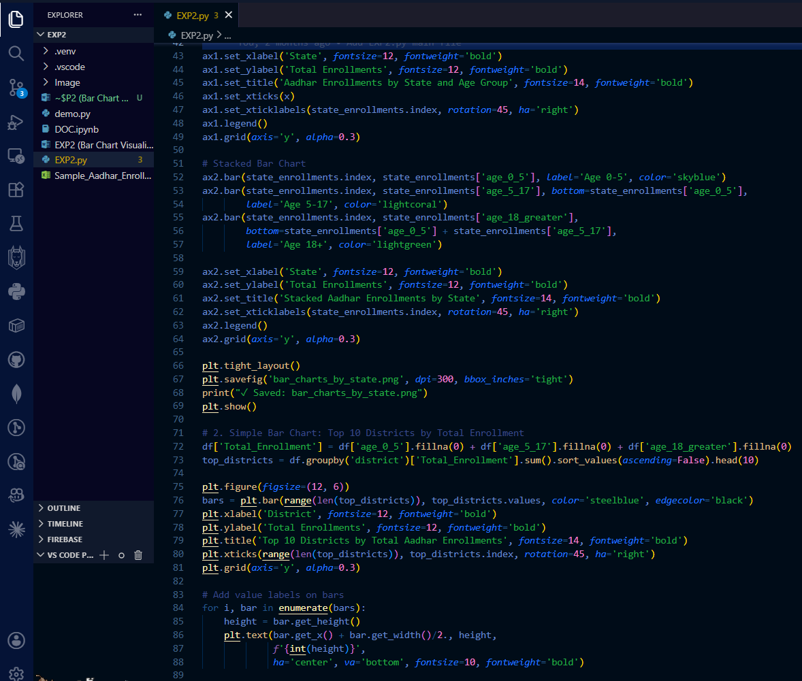

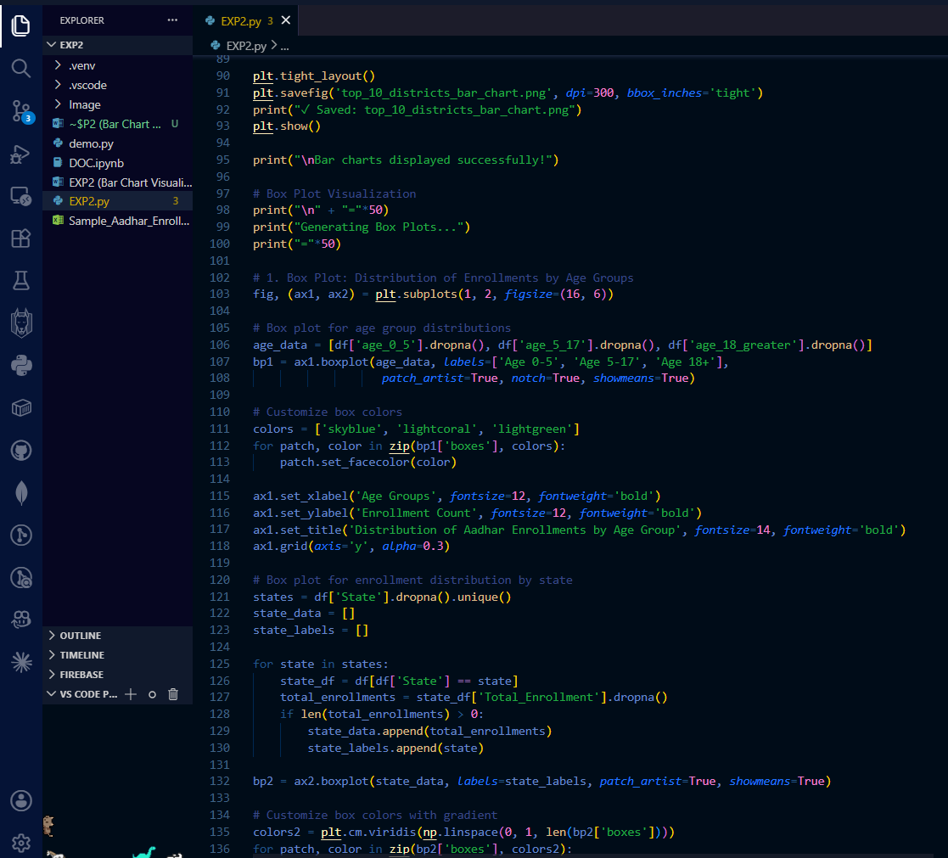
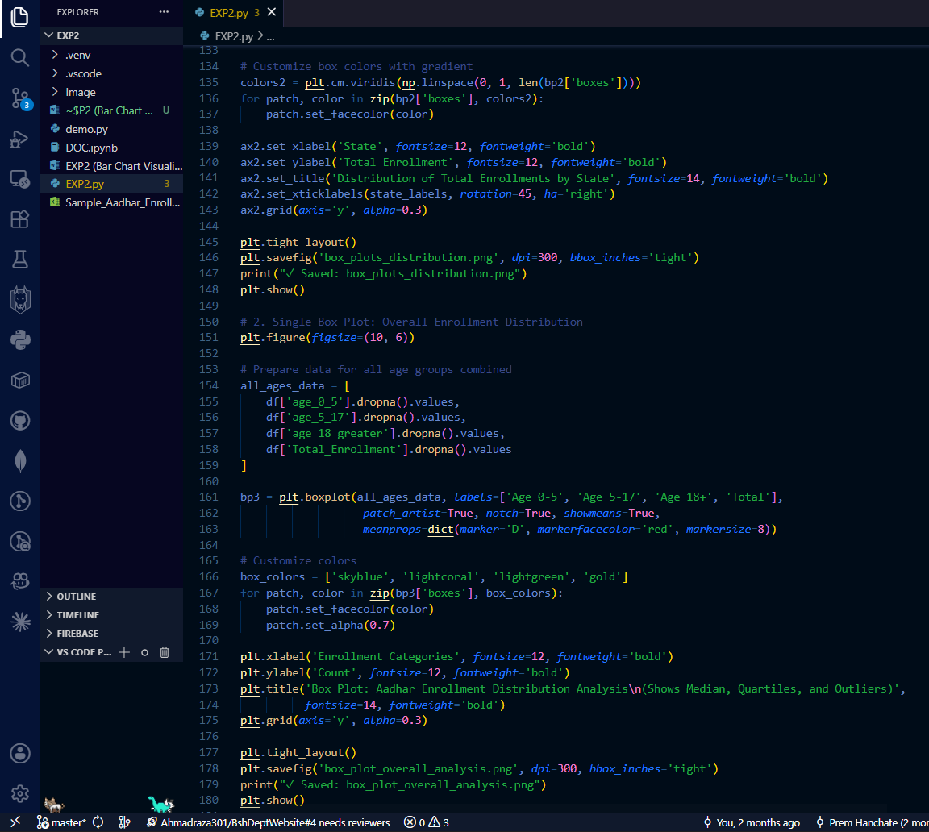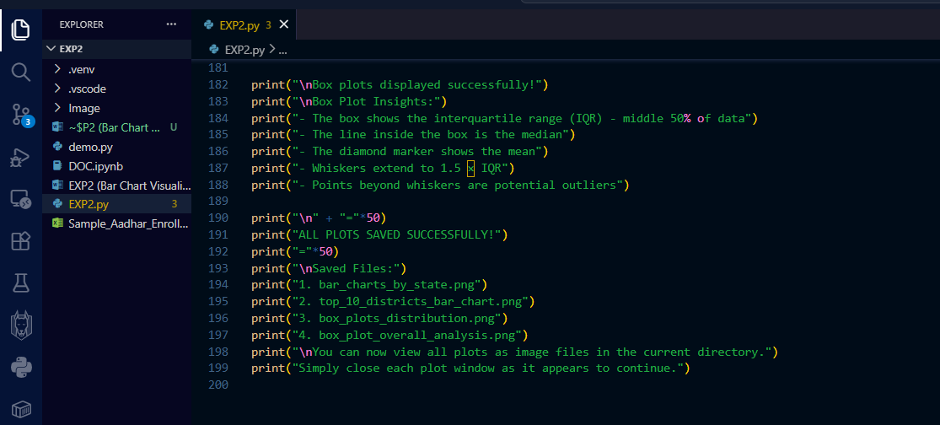

Output

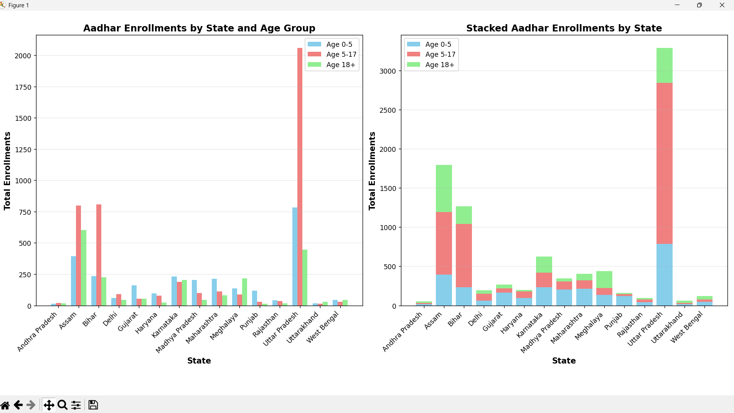
Chart’s Visualizations Created:
- Grouped Bar Chart (Left panel)
  - Compares enrollments across different states
  - Shows three age groups side-by-side for each state
  - Uses different colors: Age 0-5 (blue), Age 5-17 (coral), Age 18+ (green)
- Stacked Bar Chart (Right panel)
  - Shows total enrollments per state
  - Age groups stacked on top of each other
  - Gives a clear view of total enrollment volume per state
The bar charts are ideal for this dataset because they clearly compare categorical data (states/districts) with enrollment counts across different age groups, making it easy to identify patterns and regional differences in Aadhar enrollments.
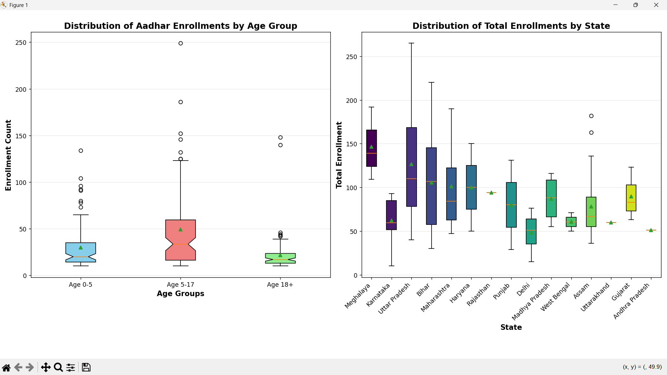

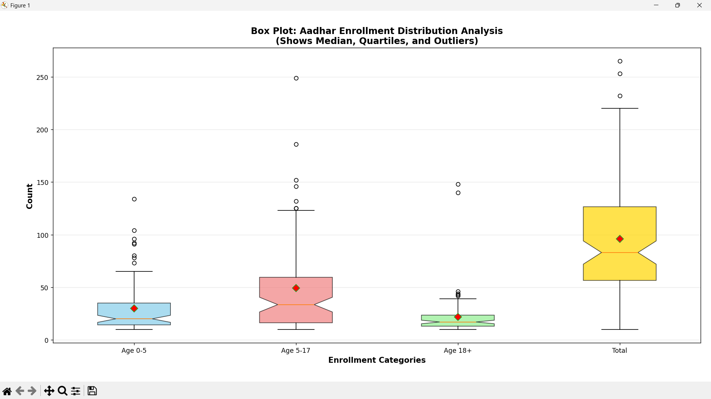

High Performing States
- Uttar Pradesh
Highest overall enrollment in both graphs
- Age 5–17 → Extremely high (largest among all states)
- Age 0–5 → Very high
- Age 18+ → Moderate but still large compared to many states
Uttar Pradesh is the top performing state with maximum Aadhaar enrollment, especially among school-age children.
- Assam
Second highest performer
- High enrollment in Age 5–17
- High enrollment in Age 18+
- Good enrollment in Age 0–5
Assam shows balanced and strong performance across all age groups.

Equal Performing States
These states show balanced but medium-level enrollments.
- Karnataka
- Almost equal enrollment in all age groups
- Moderate totals
Shows balanced Aadhaar awareness and participation.

Low Performing States
These states show lowest Aadhaar enrollment totals.
- Andhra Pradesh
- Very low enrollments across all age groups
- Uttarakhand
- Low enrollment in all age groups
- Still falls in low performance group

Age Group Wise Performance Insight
Age 0–5 (Children)
- Highest → Uttar Pradesh
- Good → Assam, Bihar
- Lowest → Andhra Pradesh, Jharkhand

Age 5–17 (School Age)
- Highest → Uttar Pradesh (dominates strongly)
- Second → Assam & Bihar
- Lowest → Andhra Pradesh, Gujarat

Age 18+
- Highest → Assam
- Moderate → Uttar Pradesh
- Lowest → Andhra Pradesh, Jharkhand

TOP 10 Districts by Total Aadhar Enrollment
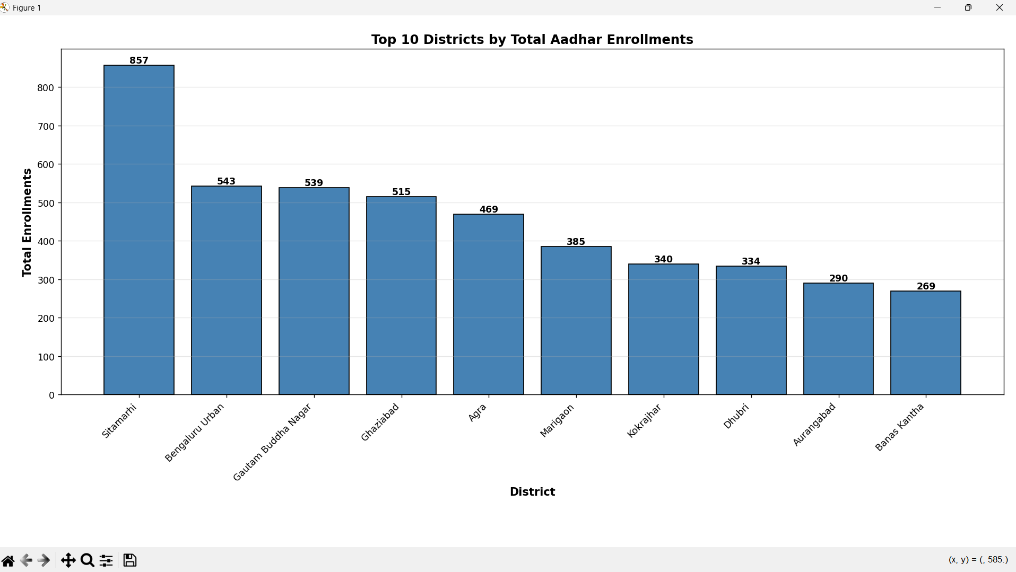

Conclusion
In this experiment, data visualization was successfully performed on the Aadhar Enrollment dataset. A new Total_Enrollment column was derived by summing the three age-group columns. Grouped and stacked bar charts revealed the distribution of enrollments across age groups for each state, highlighting which states had higher participation in specific age brackets. The Top 10 districts bar chart with value labels made it easy to identify the highest-enrolling districts at a glance. Box plots provided insight into the spread, median, IQR, and outliers of enrollment counts across age groups and states. Together, these visualizations offered a comprehensive and interpretable picture of enrollment patterns across India's Aadhar dataset.

